[](https://va250.org/) [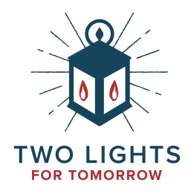](https://www.shelbycountyreporter.com/2025/03/12/gov-ivey-signs-two-lights-for-tomorrow-day-proclamation/)

* [**ABOUT**](https://va250.org/about/) \*[**THINGS TO DO**](https://va250.org/thingstodo/) \*[**PROGRAMS**](https://va250.org/signatureevents/) \* [**EDUCATION**](https://va250.org/education/) \*[**GET INVOLVED**](https://va250.org/va250localcommittees/) \*[**NEWSROOM**](https://va250.org/inthenews/)

[**Donate**](https://va250.org/donate)

**Two Lights for Tomorrow**

***A Nationwide Call to Action***

**April 11 – 22, 2025** in Virginia  
**April 18, 2025** across the nation

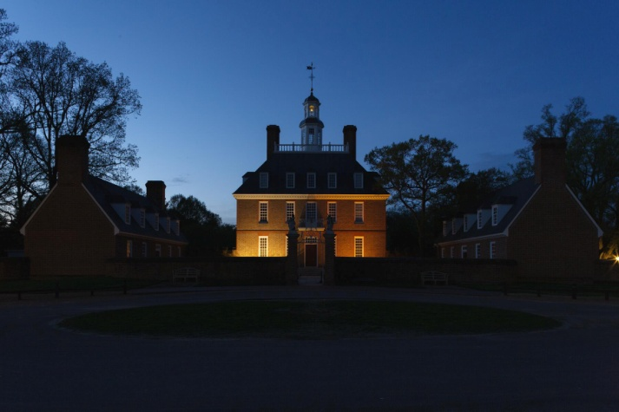

**Two Lights for Tomorrow** is a nationwide initiative to commence the celebration of the 250th birthday of the United States of America. The famous ride of Paul Revere occurred overnight on **April 18 – 19, 1775**. Two Lights for Tomorrow originated out of multi-state collaboration at *A Common Cause to All* in Williamsburg and uses the imagery of that shining light 250 years ago as a uniting call to action today for our fellow citizens, no matter where they are, to commemorate and remind ourselves that our history is about working together for a better tomorrow.

At its heart it is **a call across the country**, in private homes, local communities, and statehouses alike, for two lights to be displayed to remind us all of the importance to come together to form a more perfect union.

**How to Participate**

Everyone can participate! All you have to do is **display two lights in your homes, at your visitor centers, your cultural, historical, and community sites, and in your government buildings**in April 2025 to raise awareness and draw attention to and commemorate the beginning of our constant endeavor as a nation to work together for a better tomorrow!

**Where the Lights will Shine!**

**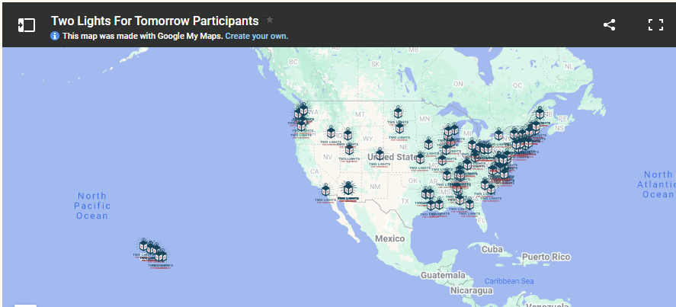**

Will you be participating? Contact Kevin Hampton at [**khampton@va250.virginia.gov**](mailto:khampton@va250.virginia.gov) to have your light added to the list!

**In Virginia**, we’ll light our lanterns from **April 11th to April 22nd**, the 250th anniversary of the Gunpower Incident in Williamsburg. We invite everyone across the state and across the nation to join us in this nationally unifying commemoration. Some states will display their lights on the anniversary itself on April 18th, others will be displaying their lights the entire month of April! Some state commissions are planning a public program as two lights are lit at the statehouses as well so be sure to check with your state’s commission for when they’re planning to participate so you can join in!

**Day of Service**

In some states, a day of service will follow the lantern lightings as a reminder that the idea of serving one another has been part of our national identity since that very first day 250 years ago.

Check with your state commission to see if they’re planning for that part or if they know of any volunteer projects ranging from park and cemetery clean-ups (especially with the close proximity to Earth Day) to community builds, food drives, and card writing to residents of care facilities, etc. The possibilities for service can be tailored to the needs of our citizens and in partnership with service organizations.

**Involve Your Community**

From two spotlights at a state capitol building beaming in the darkness to smaller displays at municipal buildings, and lights in individual homes, every citizen can participate. There isn’t a specific kind of light, duration of display, or location because the important part is just the willingness to participate!

Some governor’s offices are issuing executive orders to encourage government department buildings, municipalities, and every citizen to participate. Educational materials have been prepared by many states to engage students of all levels.

**We encourage participation at as many locations as possible – community centers, municipal and county administrative buildings, and private residences.**

**Tool Kit**

These are some toolkit assets that may help you develop your own plan which includes an event logo, signage templates, proclamation templates, and more!

* [Logos](https://drive.google.com/file/d/1R6umrwytur6ACEhiRYqM2BV2d6G-M4LR/view?usp=drive_link) (for print and digital use)
* [Signage Templates](https://drive.google.com/file/d/1P1B5qHfrNwsBXzheNpyYG0-2FBblspXE/view?usp=drive_link) (for windows, tabletop, and yard signs)
* [Proclamation Template](https://va250.org/wp-content/uploads/2025/02/Two-Lights-Participation-Proclamation-Template.docx)
* [Educational Materials](https://drive.google.com/file/d/1E26FF75AMP0DZjkFOGLXQQMG6Wm7Nfqz/view?usp=drive_link)
* **Coloring Sheets**
  + [Sheet 1](https://va250.org/wp-content/uploads/2025/04/TwoLightsforTomorrowColoringPage.png)
  + [Sheet 2](https://va250.org/wp-content/uploads/2025/04/TwoLightsforTomorrowColoringPage2.png)

**In The News**

[[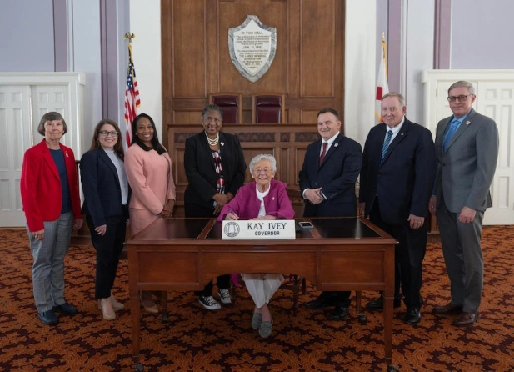](https://www.shelbycountyreporter.com/2025/03/12/gov-ivey-signs-two-lights-for-tomorrow-day-proclamation/)](https://www.shelbycountyreporter.com/2025/03/12/gov-ivey-signs-two-lights-for-tomorrow-day-proclamation/" \t "_blank) **[Gov. Ivey signs Two Lights for Tomorrow Day Proclamation](https://www.shelbycountyreporter.com/2025/03/12/gov-ivey-signs-two-lights-for-tomorrow-day-proclamation/" \t "_blank)**

**[Contact](https://www.shelbycountyreporter.com/2025/03/12/gov-ivey-signs-two-lights-for-tomorrow-day-proclamation/" \t "_blank)** [Kevin Hampton VA250 Assistant Director, Programs & Education](https://www.shelbycountyreporter.com/2025/03/12/gov-ivey-signs-two-lights-for-tomorrow-day-proclamation/) [**khampton@va250.virginia.gov**](mailto:khampton@va250.virginia.gov)[Facebook](https://va250.org/#facebook)[Mastodon](https://va250.org/#mastodon)[Email](https://www.addtoany.com/add_to/email?linkurl=https%3A%2F%2Fva250.org%2Ftwo-lights%2F&linkname=Two%20Lights&linknote=)[Share](https://www.addtoany.com/share#url=https%3A%2F%2Fva250.org%2Ftwo-lights%2F&title=Two%20Lights)